M250DP Synergic Pulse Welding System
MIG, TIG & Stick 250 Amp Inverter (208-240VAC)

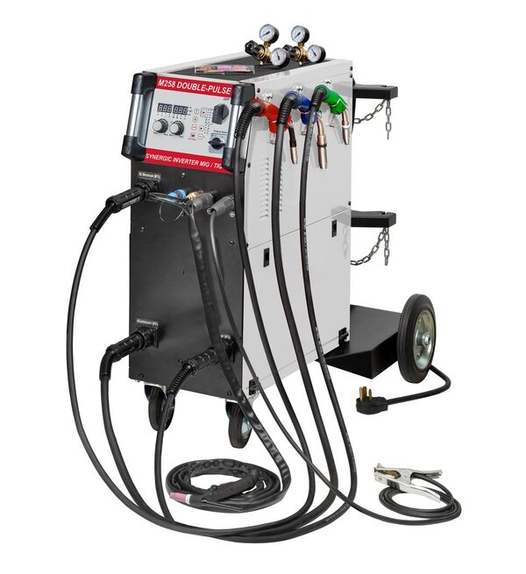

M250DP

The M250 Synergic Pulse Multi-purpose MIG/TIG/STICK welder is the choice of automotive repair professionals with unparalleled performance. This compact machine offers four MIG welding modes: manual, synergic, synergic single-pulse, synergic double-pulse programs and three wire feed torch drives for steel, aluminum and silicone bronze welding with wire sizes from .023”-.045”. The unit also features lift-arc DC TIG and stick electrode welding capability. With 250 amps of power, it is capable of welding all steel and aluminum alloys from #20GA to ½”. Additionally, it offers twin cylinder racks and dual gas inputs for mixed and 100% gases.

System features IGBT high efficiency inverter power supply with epoxy sealed components in a compact air-cooled cabinet with the highest duty-cycle rating in class. Operating features include digital control panel with LED displays, infinitely variable output power from 10-250 amps and operator selectable pre & post gas, slow feed, burn back, spot, ramp, slope, frequency, duty, arc length, spool gun, hot start, and arc force.

Package includes high efficiency inverter power supply with three dedicated MIG guns (Steel, Aluminum & Silicone Bronze), compact TIG torch with thumb-wheel control & quick-connect welding cable 12.5’, 250A electrode holder with quick-connect welding cable 10’, 250A ground clamp with quick-connect welding cable 10’, dual gas regulators, AK-2 torch kit, spools of steel, aluminum and silicone bronze wire, “V” & “U” drive rolls & contact tips and complete operator manual with all programs.

Input Power: 208-240VAC Single-P 50/60 Hz Output Power: 30-250 Amps (DCV)
Input Current: 35 Amps (NEMA 6-50P Cord) Duty-Cycle: 30% @ 250 Amps
Dimensions: 41” x 12.62” x 36.5” (105 X 32 X 93) Weight: 172 Lbs. (78 Kg)
Inner carton: 33.5” X 24.8” X 34.25” (85 X 63 X 87) Shipping Weight: ~220 Lbs.

