INTRODUCTION

Congratulations on your Portable Plasma Cutter purchase. You have purchased one of the most reliable, technologically advanced and economical portable plasma cutters available today. This machine will allow you to cut almost any material that conducts electricity including mild steel, galvanized steel, stainless steel, and aluminum to name a few.

This owner’s manual has been designed to instruct you on a safe operation and maintenance of your Plasma Cutting System. If you read and follow the instructions in this manual, your Plasma Cutter will provide you with years of trouble free operation.

If you do not read and understand this owner’s manual, you MAY significantly shorten the operating life and may also operate the unit under unsafe conditions, which may result in SERIOUS INJURY OR DEATH!

If you have any questions regarding the information contained in this manual, contact your local distributor or the factory help line @ 800-554-0074.

SAFETY

Follow Safety Instructions – Read carefully all safety messages in this manual and safety labels on the machine. Do not let anyone operate the machine without complete understanding of the safety instructions.

Electric Shock Can Kill – Personal contact with live electrical parts can cause fatal shock or severe burns. The torch uses high voltage (>250VDC) and produces an electrical arc in excess of 10,000°F. Never touch the torch body, workpiece, ground clamp or the cutting table water when the cutter is in operation as a shock could result.

Electric Shock Prevention

- Wear insulated gloves and boots.
- Insulate operator from work and ground with mats or covers.
- Always operate machine in a dry environment.
- Use fixtures or clamps to secure workpiece in place.
- Provide earth ground to work, fixtures, tables and water tray.
- Inspect all electrical cables for damage, wear or exposed copper.
- Never bypass or short-cut machine ground.
- Disconnect power cord before checking, replacing components or servicing machine.

SAFETY (cont.)

Plasma Arc Can Burn Operator – The arc will cut through protective gloves, boots and clothing as well as human skin and bone.

- Keep away from the torch tip and arc.
- Do not hold metal near the cutting arc.
- Never point the torch towards yourself or others.

Plasma Arc Ray Can Damage Eyes – Plasma Arc rays produce intense visible and invisible (ultraviolet & infrared) rays that can cause eye damage. Protective eyewear should always be worn when operating the plasma cutter.

- Wear safety glasses, goggles or welding helmet with proper lens shading.
- Install UV blocking safety screens around work area.
- Install warning signs instructing people not to watch the arc.

Recommended Lens Shade

Arc Current <100 Amps #8 (AWS) #11 (ISO 4850)

Arc Noise Can Damage Hearing – Prolonged exposure to noise can damage hearing. Appropriate hearing protection should be worn during operation.

Cutting Can Cause Fire or Explosion – The plasma cutter generates an arc with intense heat to cut through material. This heat can ignite flammable materials, including gases, on contact leading to fire or explosion.

Fire & Explosion Prevention

- Keep a fire extinguisher (correctly shielded) close to the work area.
- Remove all flammable material within 35 feet of work area.
- Provide adequate ventilation of explosive dusts and gases.
- Never cut pressurized cylinders, pipes or any closed container.
- Never cut containers or tanks that have held combustible materials
- Do not use oxygen or other flammable gases as cutting plasma gas.

SETUP & OPERATION

Initial Machine Inspection – Inspect the machine, torch and all components included in the shipping carton.

Contact your retailer or distributor and report any missing items. Have your machine model and serial number ready for any claim.

Contact your freight carrier immediately if unit was damaged in shipment and file a claim. All damage claims are the responsibility of the carrier that damaged the unit and any copies of bills of lading or other required materials, will be furnished by your retailer or distributor.

Contents of Carton – Your plasma cutting system includes the following items:

- Plasma cutting machine with the following attachments:
- Plasma cutting torch with 13 foot cable assembly.
- Heavy-duty work clamp with cable assembly
- Power cord with 3-prong UL plug.
- ¼” NPT air line connector
- Spare cutting tips (bag containing 5 pieces)
- Spare Electrodes (bag containing 3 pieces)
- Operators manual

Machine Setup – Before beginning any cutting operations it is important to set the machine up correctly. The machine will not function properly without careful attention to the line power supply, compressed air supply, work grounding clamp and torch contact.

Electrical Power Supply – The machine supply voltage is clearly labeled on the back of the machine near the power cord. Note the following required NEMA outlets and corresponding minimum supply Amps for operation.

Line Power Requirements

Voltage Amp (min) Cycles (Hz) Outlet

120 Volt 20A 60Hz 5-15R

240 Volt 15A 60Hz 6-15R

NOTE: Insufficient line voltage or amperage can cause the torch not to fire.
Compressed Air Supply – The machine requires clean & dry air with adequate head-pressure and flow-rates of for optimal operation. The air for cutting can be supplied by a shop compressor or air cylinder with a high-pressure regulator. It is recommended that an external air filter & dryer unit be attached directly to the machine air inlet.

Clean - The torch has internal air ports that are smaller in diameter than a human hair. If these ports become blocked, reduced cutting capacity and overheating can occur.

Dry – The plasma arc is generated with a high voltage charge of electricity ionizing the compressed air. Any water in the air will result in arc grounding, which reduces cutting power. Additionally, the extreme temperature of the arc will cause the water to instantaneously turn to steam that can damage the torch.

Pressure – A minimum air pressure of 72 PSI (5.0 bar) is required. Pressures in excess of 120-PSI (9.4 bar) can damage the machine.

Flow – A minimum flow rate of 4.5 scfm (127 l/min) is required for cool operation of the cutting torch. Insufficient flow rates will reduce cutting depths, reduce consumable life and can result in complete torch failure.

NOTE: If the supply-line is disconnected from the machine or the air pressure drops below 30 PSI, the low-air limit switch will engage
and the torch will not fire.

Air Hose Mounting – The supply line air hose that is attached the plasma cutter should be of sufficient size and construction to insure safe operation.

Fitting – A factory supplied ¼” NPT male air inlet fitting is located on the back of the machine. When attaching the filter/dryer, quick dis-connect coupler or air hose fitting be sure to use liquid pipe sealant only.

Hose – An air hose with a minimum inside diameter of 3/8” (9.5mm) should be used on the machine to insure adequate airflow.

NOTE: Never use Teflon tape on this fitting as small pieces of the tape can break off and block the flow of air to the machine.

Work Clamp Mounting – The work clamp must be attached to the workpiece while cutting and should be as close to the cut area as possible. Make sure that the surface under the clamp is free of contamination or paint that could interfere with the electrical connection. Do not attach the clamp to the piece of material that is being cut.
Operating the Plasma Cutter – Now that all of the necessary setup connections and work area conditions have been made, you are ready to start cutting with your new plasma machine.

Power ON – With the torch cable completely uncoiled and making sure the trigger is not depressed, turn the power switch to the “ON” position. At this time you see the toggle switch light go on and will hear the internal cooling fan energize.

Air ON – Check to see that the machine is receiving supply air by reading the air pressure gauge on the front panel. The air regulator is factory set for optimal performance between 45-60 PSI and initial adjustment should not be necessary.

Torch READY – The torch should be held 1/16” off the edge, or directly in contact with the surface for a piercing cut, of the workpiece.

Trigger ON – Depress the trigger and the torch will fire. Move the torch to the workpiece, setting the tip directly on the surface as you move through the material. This insures a clean, smooth cut with minimal back spatter.

Cutting Torch Operation – The Nu-Tec torch provides the latest in plasma cutting torch technology with a compact ergonomic design for ease of operation.
The torch is designed for contact cutting on both the 25 & 35 units.

Cutting – Hold the torch so the flat end of the cutting tip is parallel to the cutting surface and just off the edge. Start the torch against edge of the workpiece and move it into the material making light contact as you cut. If sparks fly up at the operator, you are moving the torch too fast.

Piercing – When a pierce (start) hole is required, hold the torch straight down to the surface and hold it fixed in place until the flash sparks stop and the sparks shoot through the material. Then move across the surface in a standard cutting mode.

Work Clamp – Always make sure the work clamp is attached to the cutting surface. The work clamp completes the electrical circuit during high amperage cutting, which reduces the load on the torch cable.

WARNING
Firing the torch more than 1/8” from the cutting surface greatly reduces consumable life and may cause permanent torch damage.

MAINTENANCE & REPAIR

Installing / Replacing Torch Consumables – Now that you have completed some cuts and noticed reduced cutting speed, reduced cutting depth, or a ragged edge, it is time to replace the torch consumables.

WARNING
The power switch should be in the “OFF” position and the line cord should be disconnected from the outlet while replacing torch consumables.

Benchtop – The torch should be resting on a bench surface with the tip facing up during disassembly and re-assembly. The work area should be clean of all debris as the torch components contain very small air ports that are easily contaminated. Items that drop from the torch should be cleaned and inspected before re-installing.

Shield Cup – Loosen the shield cup by turning counter-clockwise from the cutting tip end. Inspect for debris, surface burn-through and/or damage to the inner bore towards the top of the cup. If the cup is severely burned and/or any cooling air ports are blocked, replace the cup.

Cutting Tip – Lift the cutting tip off the torch body and inspect for wear. If the center hole diameter is larger than 1/16” and/or not round, replace the tip.

Swirl Ring – The swirl ring (gas diffuser) is mounted at the base of the cutting tip and channels the cutting gas across the electrode. Inspect for cracks or plugged air holes and replace as required.

Electrode – The electrode may be removed by simply putting a wrench or pliers on the flats and turning loose like a screw. Inspect for wear and pitting. If the work end is pitted (concave) or burned away by 1/16” as compared to a new electrode, replace with new electrode.

Torch Head – While the torch is disassembled, it is a good idea to inspect the complete torch head for signs of clogged air ports or damaged o-rings. The torch head should not require replacement except in the event of contamination (water, oil or dirt in the air supply) or overheating due to poor maintenance. If the torch head is deformed due to excessive heat, dis-assemble handle and replace

Re-assembly – Take care to return components to their original position, especially the swirl ring, and “snug” shield cup into place. Do not over-tighten shield cup as damage to the internal torch tip components may result.

Troubleshooting Guide

 | Problem | Procedure
1. | Power "ON" light not illuminated | Power cord not plugged into outlet - Plug-in cord
 |  | Outlet not energized - Check circuit breaker/dis-connect
 |  | Low Voltage - Check for proper line voltage at outlet
2. | Cooling fan not running | Power switch in "OFF" position - Switch power "ON"
 |  | Finger guard blocking fan blade - Bend away from blade
3. | No or low air pressure on gauge | Air line not attached to machine - Attach air line
 |  | Air supply line shut-off - Turn air supply "ON"
 |  | Regulator set too low- Pull knob and adjust
 |  | Filter/dryer devices installed incorrectly - Repair
4. | Torch does not fire - no air flow through torch | Power is switched "OFF" or not connected - See #1
 |  | Air pressure is off or too low to ignite torch - See #3
 |  | Shield Cup not correctly installed - See Consumables
5. | Torch does not fire - air flow through torch | Low supply voltage- Check outlet voltage
 |  | Air pressure too high - Adjust to 65 psi
 |  | Torch missing or failed components - Check torch
 |  | Worn /damaged cutting tip - Replace
 |  | Worn/damaged electrode - Replace
6. | The arc will not stay "lit" | Air pressure is set too high - Reduce pressure setting
 |  | Inconsistent air flow - Check for contamination & filter
 |  | Worn or damaged consumables - Replace consumables
 |  | Low or varying voltage - New service or add transformer
 |  | - Remove extension cord
7. | The arc "Sputters" and flares | Check for water in air line - Add air dryer
 |  | Check for contamination in air line - Add air filter
8. | The arc does not transfer to the workpiece | Work Clamp failure - Check clamp location & connection
 |  | Torch is too far from workpiece - Move torch within 1/8"

Technical Questions – In the event additional assistance is required beyond the scope of this trouble-shooting guide or custom plasma products are desired, please contact your local distributor or the factory direct line at 800-554-0074.

NPT40 Plasma Torch Consumables

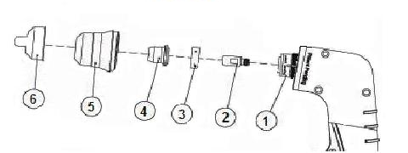

1) Torch Head 70° 907N9602 2) Standard Electrode 907N0110
3) Swirl Ring/Gas Diffuser (20-50A) 907N0106 4) Cutting Tip (30A) 907N1168 5) Shield Cup 907N1160 Cutting Tip (20A) 907N1167
6) Stand-Off (40Amp only) 907N0010

Specifications – Power Supply

Rated Power Supply | Single Phase / 60 Hz
Rated Input Current (I1) & Voltage (U1) | 20A @ 120 Volts / 16A @ 208 / 14A @ 240 Volts
Rated Output Current (I2) | 18A @ 120 Volts / 25A @ 208 / 28A @ 240 Volts
Rated Open Circuit Voltage (Uo) | 290 VDC
Rated Output Voltage (U2) | 94 VDC
Duty-Cycle @ 40°C | 60%
Air/Gas Pressure (Min.) | 60 PSI (4.2 bar)
Air/Gas Flow Rate (Min.) | 4.5 scfm (127 l/min.)
Weight (Shipping Carton) | 46 Lbs.

NPT40 Plasma Cutting Torch – Parts List
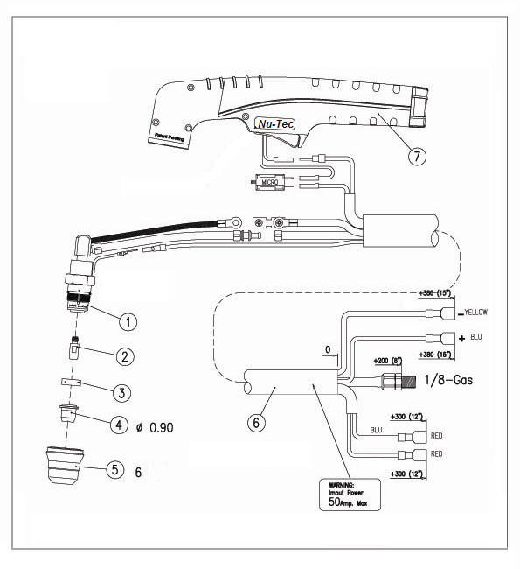

Operator Manual 25/35, Rev 3. (May 2006)

