Part # 740.0000



2016.03

2016-03

Processes


Plasma

110-240VAC Plasma System

AIR PLASMA CUTTER

PCA48 PFC

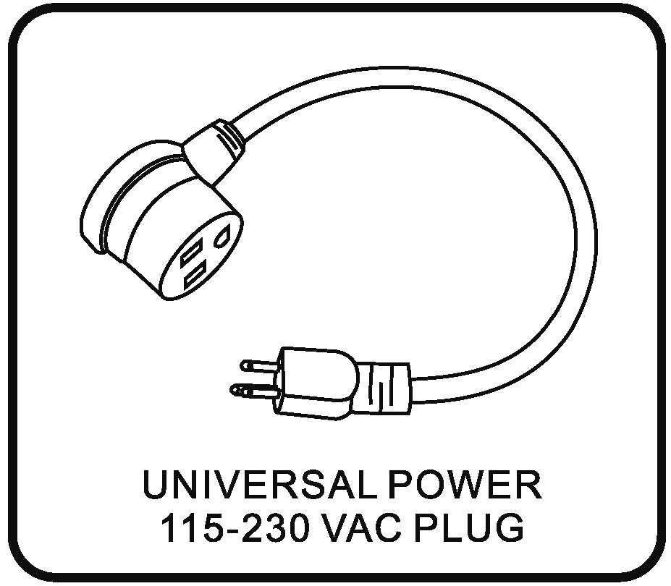
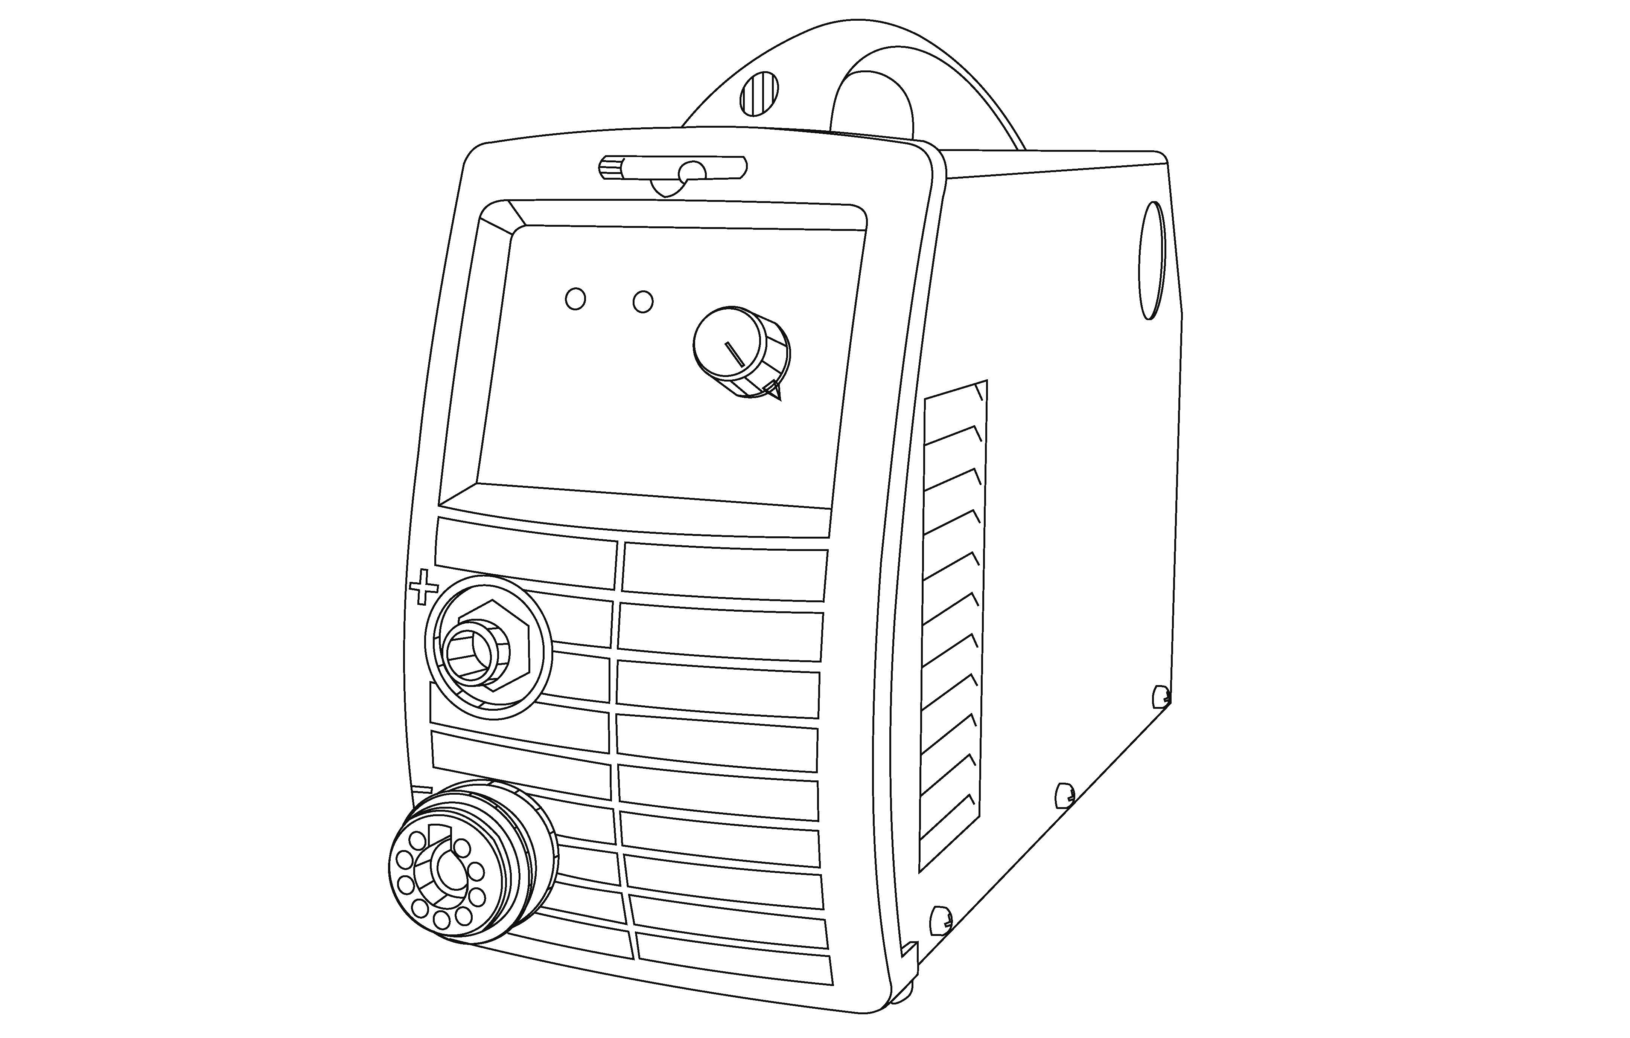

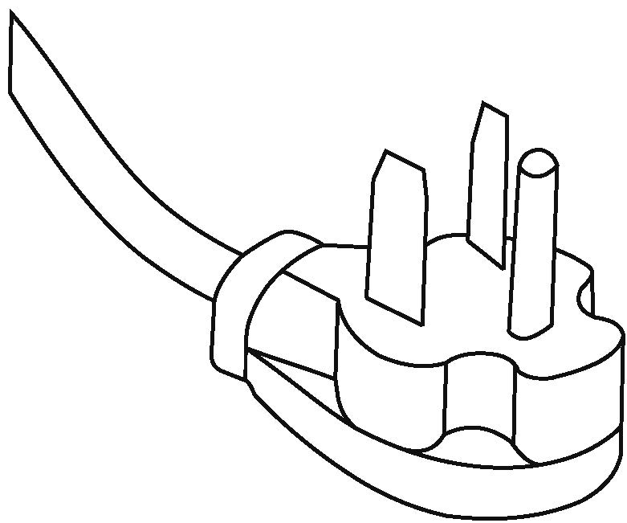

OPERATOR’S MANUAL

.
CONTENT
§1 SAFETY 1
§2 technology parameters 3
§2.1 Parameters 3
§3 Installation 4
§3.1 Unpacking 4
3.2 Input power connections 4
§3.3 Gas connections 4
§4 Operation 5
§4.1 Layout for the front rear panel(take the CUT40 for example) 5
§4.2 Cutting Preparation 6
§4.3Cutting Operation 6
§5 Maintenance 7
§5.1 Basic Troubleshooting Guide 7
§5.2 Troubleshooting Principle 8
§5.3 NPT48 Plasma Torch Consumables 10
§5.2 Electrical principle drawing 11
§5.3 Partslisting 11

§1 SAFETY

Important Safety Precautions

OPERATION AND MAINTENANCE OF PLASMA ARC EQUIPMENT CAN BE DANGEROUS AND HAZARDOUS TO YOUR HEALTH.
Plasma arc cutting produces intense electric and magnetic emissions that may interfere with the proper function of cardiac pacemakers, hearing aids, or other electronic health equipment. Persons who work near plasma arc cutting applications should consult their medical health professional and the manufacturer of the health equipment to deter- mine whether a hazard exists.
To prevent possible injury, read, understand and follow all warnings, safety precautions and instructions before using the equipment.

GASES AND FUMES


Gases and fumes produced during the plasma cutting process can be dangerous and hazardous to your health.
• Keep all fumes and gases from the breathing area. Keep your head out of the cutting fume plume.
• Use an air-supplied respirator if ventilation is not adequate to remove all fumes and gases.
• The kinds of fumes and gases from the plasma arc depend on the kind of metal being used, coatings on the metal, and the different processes. You must be very careful when cutting or cutting any metals which may contain one or more of the following:

Antimony | Chromium | Mercury | Beryllium
Arsenic | Cobalt | Nickel | Lead
Barium | Copper | Selenium | Silver
Cadmium | Manganese | Vanadium

Always read the Material Safety Data Sheets (MSDS) that should be supplied with the material you are using. These MSDSs will give you the information regarding the kind and amount of fumes and gases that may be dangerous to your health.
• Use special equipment, such as water or down draft cutting tables, to capture fumes and gases.
• Do not use the plasma torch in proximity to combustible or explosive gases or materials.
• Phosgene, a toxic gas, is generated from the vapors of chlorinated solvents and cleansers. Remove all sources of these vapors.

ELECTRIC SHOCK

Electric Shock can injure or kill. The plasma arc process uses and produces high voltage electrical energy. This electric energy can cause severe or fatal shock to the operator or others in the workplace.
• Never touch any parts that are electrically “live” or “hot.”
1

• Wear dry gloves and clothing. Insulate yourself from the work piece and live torch parts.
• Repair or replace all worn or damaged parts.
• Extra care must be taken when the workplace is moist or damp.
• Disconnect power source before performing any service or repairs.
• Read and follow all the instructions in the Operating Manual.

FIRE AND EXPLOSION

Fire and explosion can be caused by hot slag, sparks, or the plasma arc.
• Be sure there is no combustible or flammable material in the workplace.
• Ventilate all flammable or explosive vapors from the workplace.
• Do not cut or weld on containers that may have held combustibles.
• Provide a fire watch when working in an area where fire hazards may exist.
• Hydrogen gas may be formed and trapped under aluminum work-pieces when they are cut underwater or while using a water table. DO NOT cut aluminum alloys underwater or on a water table unless the hydrogen gas can be eliminated or dissipated. Trapped hydrogen gas that is ignited will cause an explosion.

NOISE

Noise can cause permanent hearing loss. Plasma arc processes can cause noise levels to exceed safe limits. You must protect your ears from loud noise to prevent permanent loss of hearing.
• Operator should wear protective ear plugs and/or ear muffs. Protect others in the workplace.
• Noise levels should be measured to be sure the decibels (sound) do not exceed safe levels.

PLASMA ARC RAYS

Plasma Arc Rays can injure your eyes and burn your skin. The plasma arc process produces very bright ultra violet and infrared light. These arc rays will damage your eyes and burn your skin if you are not properly protected.

• Wear safety glasses with specified UV/IR DIN 1.7-6.0 with side shields other protective eye wear.
• Wear cutting gloves and suitable clothing to protect your skin from the arc rays and sparks.
• Keep helmet and safety glasses in good condition. Replace lenses when cracked, chipped or dirty.
• Protect others in the work area from the arc rays. Use protective booths, screens or shields.

§2 Technology Parameters

§2.1 Parameters
Models  Parameters | PCA48 PFC
Input power | 110-220VAC, Single-Phase，50/60Hz
Rated input current（A） | 21(220V)  31(110V)
Rated input power（KW） | 4.7(220V)  3.4(110V)
Adjustment range of current（A） | 20～40(220V)  20～30(110V)
Max. no-load voltage (V) | 320
Duty cycle（40℃ @ 10 minutes） | 50%(220V)  50%(110V)

Note: The above parameters are subject to change with the improvement of machines.

§3 Installation

3.1 Unpacking
Identify and account for each item per the following list:
- PCA48 Power source (with NEMA6-50 power cord and compressed air regulator/dryer)
- NPT48 Plasma Torch (with central adaptor cable connector)
- Earth Clamp Cable (with 200-amp clamp and 25-10 cable connector)
- Spare Consumables (with 3 spare Electrodes and 5 spare Cutting tips)
- Operator Manual
Inspect each item for possible shipping damage. If damage is evident, contact your distributor and / or shipping company before proceeding with the installation.

3.2 Plasma Torch & Earth Clamp Connections
Install the NPT48 plasma torch by first removing the plastic cap on the brass machine plug. Insert the plug into the female socket on the front panel being certain to align the collar with the pin detents. Screw locking collar in place to secure torch.

Install the earth clamp cable by inserting the brass plug into the female socket on the front panel being certain to align the tab with the channel and “TWIST-LOCK” into place to secure.

3.3 Input Power Connections
The PCA48 PFC plasma cutting machine features electronic switching power supply allowing it to be connected to any 110-240VAC, 1-Phase LINE power outlet.
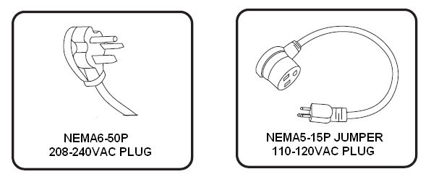
208-240VAC LINE CONNECTION: Machine is provided with NEMA 6-50P LINE Service cord to be plugged into any 6-50R outlet with 208-240VAC, single-phase power and 50-amp circuit breaker.
110-120VAC LINE CONNECTION: Machine is provided with NEMA 6-50R to NEMA 5-15P “Jumper” Service cord. This allows machine to be plugged into any 5-15R standard outlet with 110-120VAC, single-phase power and 20-amp circuit breaker.
In the event NEMA6-50R or 5-15R outlets, with rated LINE circuit breaker amperage are not available, they should be installed by a licensed electrician in accordance to all national & local codes.
In the event LINE power supply is over voltage (>245) or under voltage (<195), protection circuit inside the machine will illuminate alarm light and current will be cut off.
If the power supply voltage continually goes beyond the safe work voltage range, it will shorten the life of the machine. If this occurs, the below measures should be taken:
- Change the LINE power supply. Such as, connect the welder to a dedicated circuit.
- Shut off other machines using LINE power supply at the same time as welding.
WARNING: Any modification or removal of factory installed service power cords will VOID MACHINE WARRANTY!

3.3 Input Gas Connections
The PCA48 PFC plasma cutter is supplied with a compressed air filter/dryer and adjustable air flow knob. The air hose from the compressor should be connected directly to this air regulator. Connecting additional regulator on line can reduce air flow to the cutting torch and damage the system.
The pressure regulator should be set ~70 psi (4.8 bar) and flow rate should be 210 SCFH (100 lpm) minimum with ¼” (6mm) minimum hose diameter at 1/4G regulator input.
WARNING: Maximum Line air pressure should not exceed 125 PSI (8.6 bar)

§4 Operation

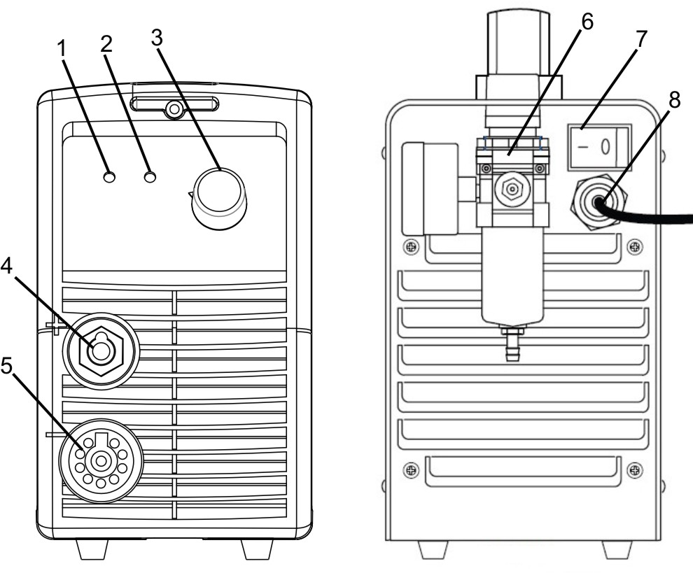
4.1 Layout of Front and Rear Panel

- Power pilot LED Illuminates when machine power is switched ON
- Alarm pilot LED Illuminates when machines exceeds duty-cycle operation (auto reset)
- Current regulator Allows operator adjustment of output cutting current
- Earth cable connector Connect earth cable from machine to the work-piece
- Torch cable connector Connect plasma cutting torch cable to the power source
- Compressed air fitting Connect compressed air hose to regulator (125 PSI maximum)
- Power switch Flip toggle to turn line power ON or OFF to machine
- Power cord Connected plug end to the appreciate power outlet (3.3 Above)
- Torch / Air pilot LED Illuminates when shield cap is removed or air pressure below 30 psi
- DC output pilot LED Illuminates when trigger is closed and DC current is flowing to torch.
- RUN / SET switch Flip toggle to SET to purge air in torch. Flip to RUN to begin cutting.

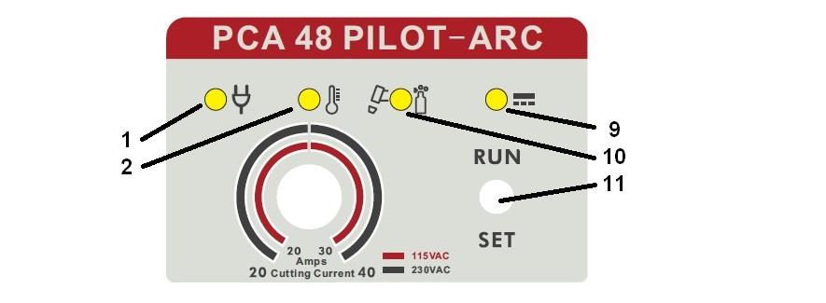

4.2 Cutting Preparation
1、Connect the power cable to electrical outlet (the input voltage, refer to the section 3).
2、Connect the air hose to the air supply equipment and set pressure to ~60 psi (4.2 bar).
3、Connect the earth cable to the workpiece not being removed with cut.
4、Make certain operator is wearing proper safety glasses (1.7-6.0 DIN) gloves and protective clothing.
5、Make certain work area is clean and free of all hazordous liquids & gases.
6、Turn ON the power switch and check the power pilot lamp is illuminated.
7、Flip RUN/SET switch to SET position for 10 seconds to purge any moisture from the torch cable.
8、Flip RUN/SET switch to RUN and machine is ready to cut.

4.3 Cutting Operation
Turn ON the power source
Release torch trigger to stop arc
Tip finishes cut on the work-piece, the cutting arc changes into pilot arc again
Place cutting tip on edge of surface

Press trigger to ignite the pilot arc
Post-gas cooling for 10 seconds
Slide tip to work-piece, changing the pilot arc into cutting arc
Arc extinguished

Notes: (1) In the event of alarm lamp ON when cutting, release torch trigger and allow unit to cool until the alarm resets and lamp goes OFF, then press on the switch to start cutting again.
(2) In the automatic air purge mode (SET), pressing trigger will not ignite arc.
(3) In the event less than 30 psi air pressure is supplied to the machine, pressing trigger will not ignite arc.
(4) After extended usage, nozzle and electrode should be changed to insure optimum cutting performance.
(5) The alarm lamp will illuminate when shield cup is removed from torch head and torch will not arc. Shiled cap must be re-installed securely in place and lamp will turn off.

§5 Maintenance
5.1 Cutting Torch Maintenance

Plasma cutting torches use ionized air (plasma) as the arc that “melts” the metal and is pushed away by the compressed air. This plasma arc exceeds 50,000°F (28,000°C) when it is pushed through the .030”-.040” (0.8-1.0mm) hole in the berylium copper cutting tip. Considering these extreme temperatures, it is easy to understand the need to replace tips & electrodes, as they become worn, and to check that all cooling air ports are clear to allow maximum air flow.

Changing Tip & Electrodes: When reduced cutting performance is observed by the operator, worn tips and electrodes must be replaced. A simple visual inspection will determine need for replacement.

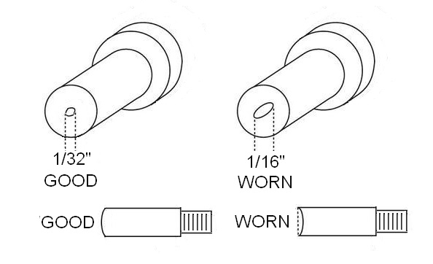

To replace tips & electrode, complete the following steps:

- Turn power switch to OFF position, making certain power pilot LED on panel is OFF (wait 5 secs.)
- Move torch head to clean work benchtop area and, with tip pointing up, remove shield cap.
- Remove cutting tip and swirl ring by lifting off electrode and place both on bench.
- Locate electrode wrench and remove electrode by rotating counter-clockwise (RH thread).
- Inspect torch head for clogged air ports or damage.
- Replace elctrode with new part and tighten with wrench. It is important to secure with wrench as electrode transfers very high DC current at vert high temperatures. A loose electrode will damage the torch head.
- Inspect the swirl ring for any damage and replace if necessary.
- Install the new cutting tip making sure to align with the step in the swirl ring.
- Inspect the shield cap, making certain no melted outer covering is blocking cooling air ports. If shield cap is burned or cover is melted, replace.
- Reinstall shield cap, making certain it is securely turned down to the base making contact with safety pins located in handle.

Inspecting Cables & Hoses: Upon completing torch consumable replacement, check all power cables, hoses and the regulator glass bowl (empty water if necessary) to make certain there is no damage. In the event of damaged insualtion on a cable, repair with proper electrical tape or shrink tubing or repalce with new assembly.

5.2 Trouble Shooting Principle

WARNING

There are extremely dangerous voltage and power levels present inside this unit. Do not attempt to diagnose or repair unless you have had training in power electronics measurement and troubleshooting techniques.

- The cutting torch fails to ignite the arc when torch trigger depressed, DC pilot light on.
1. Gas pressure too high, gas test then adjust gas pressure 60 psi (to 4.2 bar).
B. The cutting torch fails to ignite the arc, when torch trigger depressed, torch/air pilot light flashes.
1. The shield cup improper installation, turn off the power source, install and screw it down properly, then turn on the power source.
C. The cutting torch fails to ignite the arc, when torch trigger depressed, DC pilot light ON and air flows intermittently.
1.The electrode or nozzle improper installation, turn off the power source, install the electrode or nozzle, and screw shield cup down properly, then turn on the power source.
D .The cutting torch fail to ignite the arc, when torch trigger depressed, DC pilot light ON and air flows intermittently.
1. Short-circuit for burned-out and other abnormal situation, turn off the power source to change the electrode and nozzle.
E. Power lamp and temperature lamp ON.
1. Air flow blocked, check for blocked air flow around the unit and correct condition.
2. Fan blocked, check and correct condition.
3. Unit is overheated, let unit cool down for at least 5 minutes. Make sure the unit has not been operated beyond Duty Cycle limit, refer to technology parameters in Section 2.
4. Faulty components in unit, return for repair or have qualified technician repair per Service Manual.
F. Torch fails to ignite the arc when torch switch is activated
1. System is in SET mode. Change to RUN mode.

2. Faulty torch parts, inspect torch parts and replace if necessary.
3. Gas pressure too high or too low, adjust to proper pressure.

G. No gas flow with the power lamp ON and fan operating
1. Gas not connected or pressure too low, check gas connections. Adjust gas pressure to proper setting.
2. Faulty components in unit, return for repair or have qualified technician repair.
L. Torch cuts but low quality
1. Current (A) control set too low, increase current setting.
2. Torch is being moved too fast across work-piece, reduce cutting speed.
3. Excessive oil or moisture in torch, hold torch 1/8 inch (3 mm) from clean surface while purging and observe oil or moisture buildup (do not activate torch). If there are contaminants in the gas, additional filtering may be needed.

5.3 NPT48 Torch Consumables
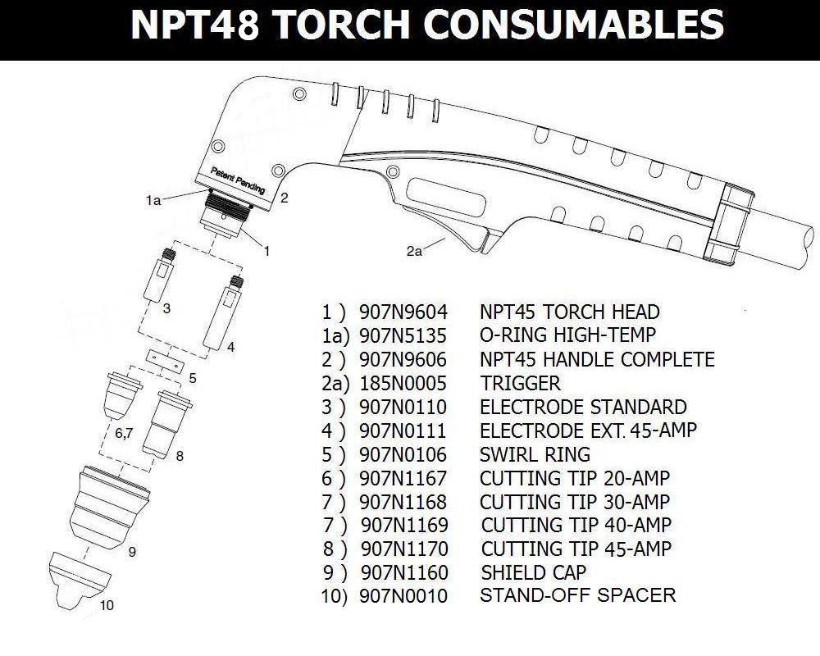

5.4 Electrical principle drawing

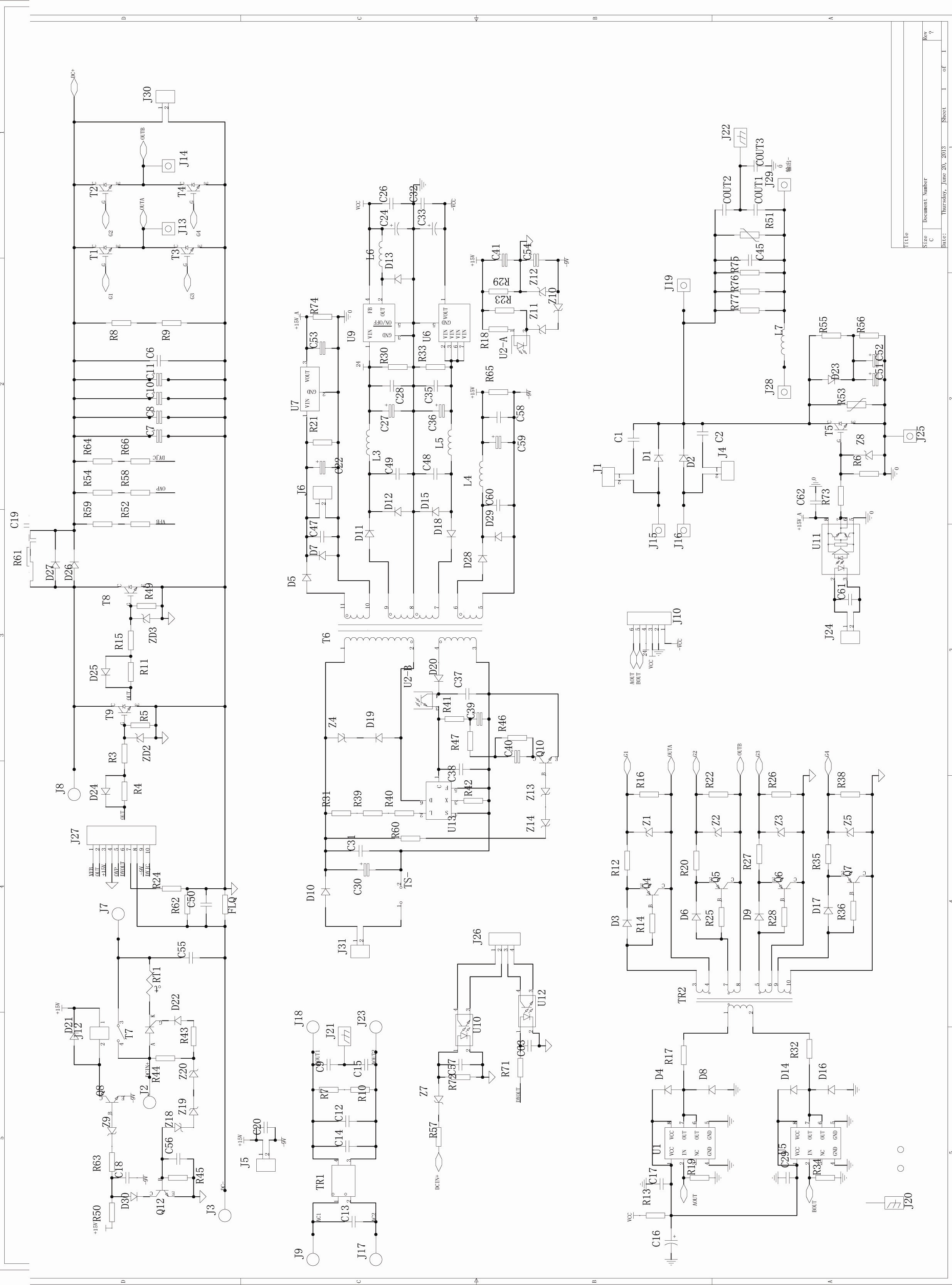

5.5 PCA48 Parts Drawing
