TG155 DC INVERTER TIG WELDING MACHINE

GB INSTRUCTION MANUAL FOR ARC WELDING MACHINE

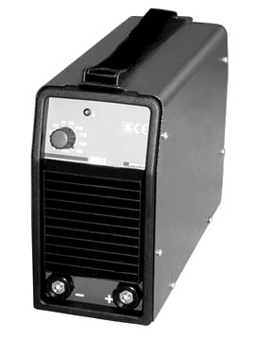

Spare parts and wiring diagram - Page 11

Nu-Tec Systems
4376 Lee Avenue
Gurnee, IL 60031
800-554-0074

INSTRUCTION MANUAL FOR ARC WELDING MACHINE

IMPORTANT
Before using this device all people authorised to its use, repair or inspection, should read the book "Safety rules for using machines" and the "Instruction manual" specific for every machine. Contact your distributor if you have not understood some instructions.
It is also essential to pay special attention to the "SAFETY RULES" Manual. The symbols next to certain paragraphs indicate points requiring extra attention, practical advice or simple information.
This MANUAL and the "SAFETY RULES" MANUAL must be stored carefully in a place familiar to everyone involved in using the machine. They must be consulted whenever doubts arise and be kept for the entire lifespan of the machine; they will also be used for ordering replacement parts.
IN CASE OF MALFUNCTIONS, REQUEST ASSISTANCE FROM QUALIFIED PERSONNEL.

1 GENERAL DESCRIPTIONS

1.1 EXPLANATION OF TECHNICAL SPECIFICATIONS
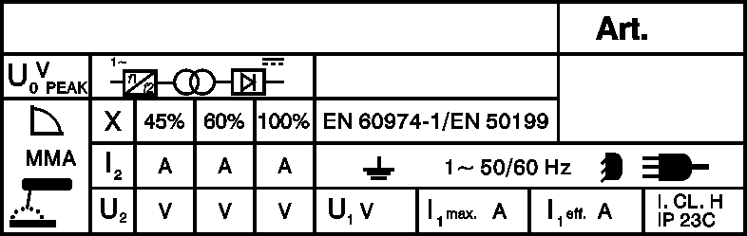
EN 60974 - 1 The welder is manufactured ac-
EN 50199 cording to this international standards
Art............................ Item number that must be stated for any demands relating to the welding machine.
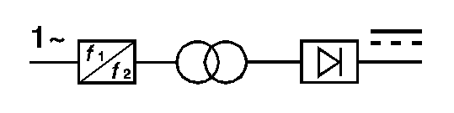.... Single-phase static frequency con-verter - transformer - rectifier.
.......................... Dropping characteristic.
MMA....................…. Suitable for manual welding with coated electrodes.
Uo............................. Secondary no - load voltage.
X.............................. Duty – cycle percentage.
The duty-cycle expresses the per-centage, calculated on 10 minutes, in which the welding machine can operate at a determined current, without over-heating.
I₂.............................. Welding current.
U₂............................. Secondary voltage with I₂ welding current.
U₁............................. Nominal supply voltage.
1 ~ 50/60Hz............. Single - phase supply 50 or 60 Hz.
I₁ max. …………….. This is the maximum value of the absorbed current
I₁ eff........................ This is the maximum value of the actual current absorbed, considering the duty cycle.
IP23C....................... Grade of protection of frame. Grade 3 as a second number means that this unit is fit to work outside under the rain.
......................... Symbol meaning that the welding machine can be used in high electric shock risk-working areas.
NOTES:..................... In addition, the welding machine has been designed to work in areas with grade 3 of pollution.(See IEC 664).

1.2 SPECIFICATIONS

This welding machine is a constant direct current generator, created by the INVERTER technology, designed for welding with coated electrodes and with the TIG procedure.
For any requests of information, please always state the item and the serial number of the welding machine.

1.3 BEFORE CONNECTING THE WELDING MACHINE
Before connecting and switching on the unit follow all safety rules and instructions as indicated in this manual. Make sure that the airflow on cooling slots is not obstructed and then proceed as follows:
1) unpack the machine
2) take care that the unit is not placed against a wall or in a position that might cut off the air; moreover, do not cover the unit's source with plastic materials, metal or paper sheets because they cause the decrease of the airflow,
3) make sure that the air temperature does not exceed +40°C,
4) do not place any filtering device over the intake air passages of this welding machine.
Warranty is void if any type of filtering device is used.

2 INSTALLATION

2.1 CONNECTION TO MAINS SUPPLY

Before connecting the unit to the mains make sure that supply voltage corresponds to the voltage indicated on the welding machine technical specification tag.

2.2 PROTECTION SYSTEM

The unit is equipped with internal protections, which assure a lasting proper operation.
These protective systems are the following:
2.2.1 Electrode anti-sticking protection
When the electrode sticks itself on the piece, the machine brings the I₂ current to not dangerous values for the electrode.
The signal light D (picture 1) indicates this operation.
2.2.2 Thermal protections
The signal light D (picture 1) indicates the intervention of this
protection. As soon as the unit has cooled down, it will be in working conditions again.
OVER VOLTAGE CAN DAMAGE THE UNIT
2.2.3 Protection against incorrect supply voltages
If the voltage is greater than 270V when the switch (A pict. 1) is turned on, the yellow led (D pict. 1) will flash briefly twice, with a brief pause between flashes, and the machine will not deliver current.
In this situation the electric circuits are protected, but the fan may burn out after a few minutes.
In the voltage low during welding, the yellow led (D pict. 1) flashes every 0.5 seconds and the machine does not deliver current.
2.2.4 Motor-driven generators
These must have a power equal to or greater than 6kVA, and must not deliver a voltage greater than 260V.

2.3 UNIT DESCRIPTION

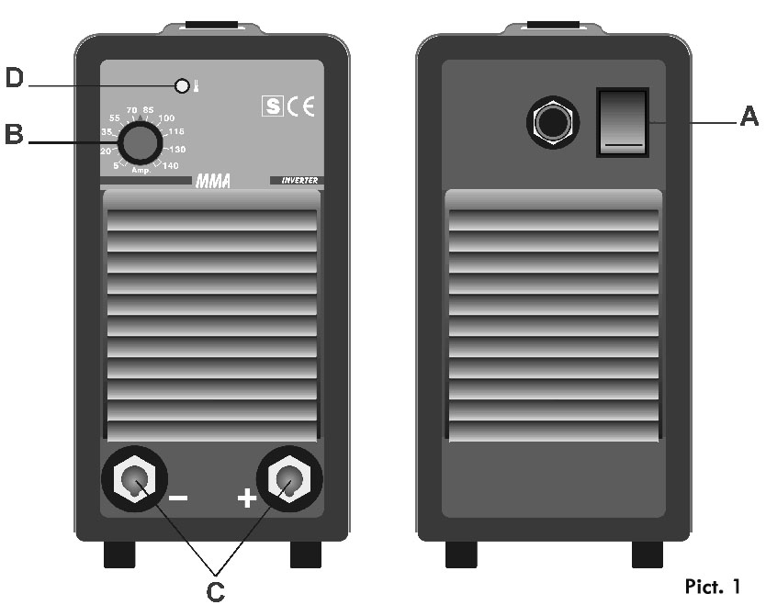
A) Input voltage general switch.
B) Welding current adjustment potentiometer.
C) Texas connections.
D) Thermal and electrode anti-sticking protections signal.

2.4 GENERAL NOTES
Before using this welding machine, carefully read the standards CEI 26/10 CENELEC HD 427 and also check insulation of cables, electrode holder clamp, sockets and plugs and that the section and length of welding cables are compatible with current used:
up to 5 m use 16 mm²,
from 5 to 20 m use 25 mm²,
from 20 to 30 m use 35 mm².

2.5 COATED ELECTRODE WELDING

- Use the electrode holder clamps in compliance with the safety standards and without projecting tightening screws.
- Make sure that the switch A (picture 1) is in O position or that the plug is not inserted in supply socket then connect welding cables in accordance with polarity demanded by the manufacturer of the electrodes which you will be using.
- Welding circuit should not be deliberately placed in direct or indirect contact with protection wire if not in the piece to be weld.
- If earthing is deliberately made on the workpiece by means of the protection wire, the connection must be as direct as possible, with the wire having a section at least equal to the welding return current wire and connected to the piece,
being worked on, in the same place as the return wire, using the return wire terminal or a second earth terminal close by.
- All possible precautions must be taken in order to avoid stray currents.
- When taking voltage from a three-phase line, be very careful when connecting the supply cable earth wire to the socket earth pole.
- Connect the supply cable. When mounting a plug, make sure that its capacity is adequate and that the yellow-green wire of the supply cable is connected to the earth plug pin.
- The sections of all extensions should be adequate to absorbed current I₁.
- Turn the machine on by means of the switch A (picture 1).
WARNING: ELECTRIC SHOCK CAN KILL.
- Do not touch live electric parts.
- Do not touch weld output terminals when unit is energized.
- Do not touch electrode holder and earth clamp at the same time.
- Adjust the current according to the diameter of the electrode, to the welding position and to the type of joint to be carried out.
When you have finished to weld, always remember to turn off the unit and to remove the electrode from the electrode holder.

2.6 TIG WELDING
- This welding machine is fit for welding with TIG procedure: stainless steel, iron and copper.
- Connect the earth cable wire to the positive (+) pole of the welding machine and the terminal to the working piece as close as possible to the welding machine, making sure there is a good electrical contact.
- Connect the connector of the TIG torch to the negative (-) pole of the welding machine.
- The welding machine circuit should not be deliberately in direct or indirect contact with protection conductor if not in the piece to be welded.
- If earthing is deliberately made on the workpiece by means of protection wire, the connection must be as direct as possible, with the wire having a section at least equal to the welding return current wire and connected to the piece being worked on, in the same place as the return wire, using the return wire terminal or a second earth terminal close by.
- All possible precautions must be taken in order to avoid stray currents.
- Connect gas pipe to pressure reducer output connected to an ARGON cylinder.
- Open the valve on the torch and regulate gas capacity.
- Use a 2% thoriated tungsten electrode chosen according to table.

electrode ø direct current
2% thoriated tungsten negative electrode
(red band) (Argon)

ø 1 mm (0,040") up to 60A
ø 1,6 mm (1/16") 60 ÷ 160A

- Make sure that mains voltage corresponds to the voltage of the welding machine.
- Connect the supply cable: when mounting a plug, make sure that its capacity is adequate and that the yellow-green wire of the supply cable is connected to the earth plug pin.
- Any extensions should have adequate sections for absorbed current I₁.

WARNING: ELECTRIC SHOCK CAN KILL!
- Do not touch live electric parts.
- Do not touch weld output terminals when unit is energized.
- Do not touch torch and earth clamp at the same time.
- Turn on the machine on with switch A (picture 1).
- Regulate current according to the work to be carried out, then open the valve placed on the torch to allow the emission of gas. Start the arc by contact, with a determined rapid movement.
CAUTION: do not use commercial ignition devices.
When you have finished to weld, always remember to turn off the machine and to close the gas cylinder valve.

2.6.1 Electrode preparation
It is necessary to pay special attention to the preparation of the electrode point, grinding it so as to obtain vertical markings as shown in picture 2.

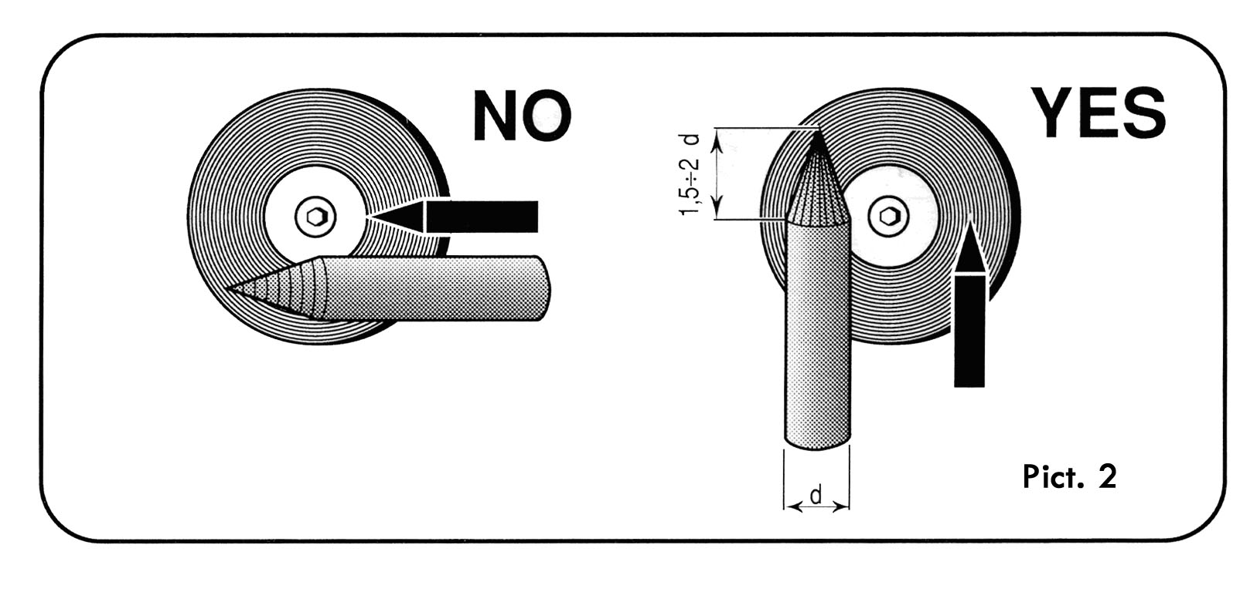
CAUTION: HOT FLYING METAL PARTICLES can injure persons, start fires and damage equipment. TUNGSTEN CONTAMINATION can lower the welding quality.
- Shape tungsten electrode only on grinder with proper guards in a safe location, wearing proper face, hand, and body protections.
- Shape tungsten electrodes on a fine grit, hard abrasive wheel used only for tungsten shaping.
- Grind the end of the tungsten electrode to a taper-shape for a length of 1,5 -2 electrode diameters (picture 2).

3 MAINTENANCE AND CHECK UP

3.1 GENERAL NOTES
WARNING: ELECTRIC SHOCK CAN KILL.
- Do not touch live electrical parts.
- Turn off welding power source and remove input power plug from socket before maintenance and servicing.
MOVING PARTS can cause serious injury.
- Keep away from moving parts.
HOT SURFACES can cause severe burns.
- Allow the cooling of the unit before servicing.

3.2 WELDING MACHINE MAINTENANCE

Experience has shown that many fatal accidents originated from servicing which had not been perfectly executed. For this reason, a careful and thorough inspection on a serviced welding machine is just as important as one carried out on a new welding machine.
Furthermore, in this way manufacturer can be protected from being held responsible for defects when the fault is someone else.

3.2.1 Prescriptions to follow for servicing:
- After rewinding the transformer or the inductance, the welding machine must pass the voltage test applied according to that indicated in table 4 of the EN 60974-1.
- If no rewinding is done, a welding machine which has been cleaned and/or reconditioned must pass a voltage test applied with voltage values equal to 50% of the values given in table 4 of EN 60974-1.
- After rewinding and/or the replacements of parts, the no-load voltage should not exceed the values given in 11.1 of EN 60974-1.
- If the servicing is not done by the manufacturer, the repaired welding machines which underwent replacements or modifications of any component should be labelled in a way such that the identity of the person having serviced is clear.

3.2.2 Precautions to take while servicing:
AN EXCESSIVE PRESSURE can break the circuit board.
Use only minimal pressure and gentle movements when disconnecting or connecting board plugs and removing or installing board.
INCORRECT INSTALLATION or misaligned plugs can damage circuit boards.
Check that plugs are properly installed and aligned before reinstalling the cover.

3.3 TROUBLE SHOOTING

DEFECT PROBABLE CAUSE REMEDY

The welding Switch in O position Switch to I
machine does not position
supply current;
completely
inoperative
Burnt fuses Replace
fuses

Plug not correctly Connect it
connected properly
_____
The welding Incorrect supply See 2.2.3
machine does voltage: yellow
not supply current signal lights up
but the ventilator
works
_____
Thermostat is open. Wait approx.
Yellow block signal 5-6 min.
lights up.

Item 135

Spare parts - Pièces de rechange - Piezas de repuesto

POS | DESCRIPTION | DESCRIPTION | DENOMINACION
1 | PANEL | PANNEAU | PANEL
2 | TEXAS CONNECTION | CONNEXION TEXAS | CONEXION TEXAS
3 | KNOB | BOUTON | MANOPLA
4 | LED HOLDER | SUPPORT LED | SOPORTE LED
5 | SWITCH | INTERRUPTEUR | INTERRUPTOR
6 | BELT | SANGLE | BANDA
7 | FAN | VENTILATEUR | VENTILADOR
8 | SPACER | ENTRETOISE | DISTÁNCIALE
9 | STRAIN RELIEF | PRESSE-ETOUPE | PRENSA CABLE
10 | SUPPLY INPUT CABLE | CABLE RESEAU | CABLE ALIMENTACION
11 | HOUSING | CARROSSERIE | CARCASA
12 | UPPER SUPPORT | SUPPORT SUPERIEUR | SOPORTE SUPERIOR
13 | LOWER SUPPORT | SUPPORT INFERIEUR | SOPORTE INFERIOR
14 | CIRCUIT | CIRCUIT | CIRCUITO
15 | FOOT | SUPPORT | SOPORTE
16 | COVER | COUVERTURE | COBERTURA
17 | FRAME | CADRE | MARCO
19 | FERRITE | FERRITE | FERRITA
36 | SWITCH COVER | PROTECTION POUR INTERRUPTEUR | PROTECCION INTERRUPTOR
In case spare parts are required please always indicate: item ref. no. and purchase date of the machine, spare part position no. and quantity.
En cas de demande de pièces de rechange, toujours indiquer: l'article et la date d'achat de la machine, la position et la quantité des pièces.
Los pedidos de piezas de repuesto deben indicar siempre: el numero de articulo y la fecha de adquisición del aparato, la posición y la cantidad de las piezas.

Item 135
Wiring diagram / Schéma électrique / Esquema eléctrico
